**APPVANE MOBILE APPLICATION – ISSUES**

**General:**

* As of now, only the Webdeveloper030303 profile has the login access; the rest of the admin profiles are unable to login
* Profile, Dashboard profile option is not accessible from home screen
* Only the Job and Logout options are accessible from the sidebar
* Job Card download option is not available
* Change the cursor color
* Email copies need to be sent to respective technician, client, admin.

**Job - Schedule Screen Section:**

* Date filter is not reflecting.
* Job list shown in the respective section does not correspond to the selected date.
* The default view shows only one job from the list instead of the entire list/no need to display the job list.
* Job list design need to be changed - (suggestion: grid view type or card type view)

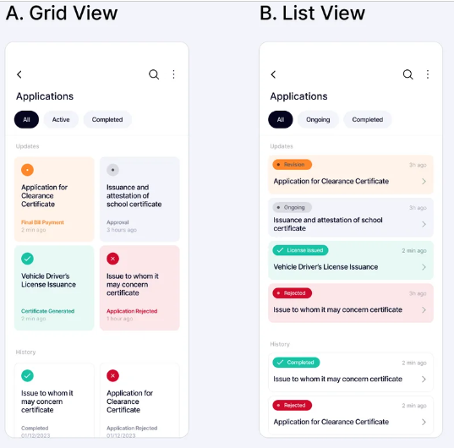

* Job Card Details:
* General:
* Job status change drop down required, instead of typing
  + The job status does not align with the status update in the employee profile from the staff login.
* Working Hours:
* The wrong date and different technician data are displayed. The technicians did not update the data as well.
* The work hours data should be shown in the admin profile job card and respective employee’s login as well (respective job card). Its should be aligned with the same data.
* Required multiple date selection in the same job card
* Add working hours order format: Left Base, Start Time, Finish Time, Return Base – Add comment box (an error occurred while adding Left Base, Start Time, Finish Time, Return Base)
* Vouchers:
  + Equipment field is calling wrong data (recalling from activities list). Show list in drop down.
* Equipment quantity entry field require only number keyboard
* Show consumable list in drop down
* Consumable quantity entry field require only number keyboard
* Remove Consumable field from mandatory field
* N-S direction locked, should be done in E-W direction as well or make it as a popup window for signing on the same page, add clear and save option on the same popup window.
* Signature field need to more specific – Pop up window
* Signature is not being saved
* Voucher prepared by field should be recall respective profile login and corresponding fields need to be auto-update accordingly
* Photograph:
  + When adding new photos, previously uploaded photos are automatically removed, allowing only one image to be added at a time. We need the option to add multiple images, both from the gallery and by taking live photos.
* Camera access required in this section to take live photos and keep the file choose option as well
* Upload:
  + Uploaded document subtitles have typo – 2 drawing subtitles are there
  + An error occurred: null check operator used on a null value pops on the screen. What is this error?
  + When reopening the job card after saving, it prompts to upload files again, even though files were already uploaded.
  + Remove the mandatory requirement from all uploading fields for now.

**Timesheet:**

* Date filter is not reflecting
* Add time sheet:
* Status field should display a dropdown menu when accessed
* Location field – display dropdown

**Attendance:**

* Date filter is not reflecting
* Attendance page is not aligned with respect to the display sizes of the different devices.
* Add attendance:
  + Dropdown required in attendance field

**Leaves:**

* Date filter is not reflecting
* Status filed name needs to be changed to Leave type from the status and need dropdown as well.
* While opening the leave request from the list, there is no proper data aligned like whose leave is that, who is approved, what is the current status (Approved, awaiting approval)
* Add leave:
  + Leave type field (currently mentioned as status field) needs dropdown list
  + Leave requested to field should be show only manager level persons/higher management, they only have the power to approve the leaves

**Assets:**

* Search field required instead of date filter option
* Not showing complete asset data list (we have updated total 95-97 assets as of now)
* Asset edit section design is not good.

**Saftey Induction:**

* Field head display as ‘equipment’s’